standbymede.org
COLLEGE FUNDING WORKSHOP
Save The Date

Get free expert help finding money to pay for college!

Date & Time:

Location:

Workshop Description:

Contact:

To learn more about financial aid programs available in Delaware, including scholarship information, visit www.delawarestudentsuccess.org. To make an appointment with a personal financial coach to help you develop a plan for college funding, visit www.standbymede.org.

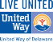
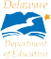
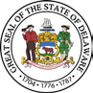
Stand By Me® is a partnership of the State of Delaware and United Way of Delaware.
The College Funding Project, a Stand By Me initiative, is funded by the Delaware Department of Education’s Higher Education Office.

